**Report of Findings (Draft #1)**

1. MATERIALS [Nick Kamarianakis]

This section of the report will cover the materials to be used for the housings of the electrical components within the bike as well as outer “shell”. The engineering principles used when conducting the research were *durability*, strength to weight ratio and cost effectiveness. These principles were used to answer the question “What is a material can keep the cyclist safe while still remaining light enough to move”. With these in mind two separate materials were chosen.

* 1. Electrical Housings

For housing the electrical components a material known as Glass-Filled Polycarbonate [1] has been chosen. For the remainder of the report, Glass-Filled Polycarbonate will be referred to as GFP. GFP has a wide variety of applications, all of which require the material to be durable and lightweight. One example of this is the housing for the HD sport camera GoProtm [2] in figure 1.

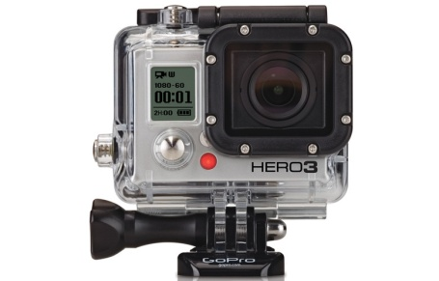

*Figure 1 : GoProtm camera with polycarbonate case [2]*

This camera housing protects the delicate electronics inside from all weather conditions as well as any damage caused from high impact sports. The GFP used in this case will be a good choice for housing the electrical components because it is highly *impact resistant* [1], has good flammability rating [3] and good electrical insulation properties [1]. Table 1 below compares the compressive strengths of GFP depending on how much glass is in the material.

*Table 1: Compressive strengths and flammability rating of polycarbonate [1]*

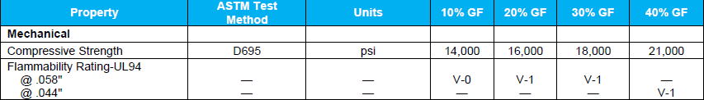

This table shows that an increase in glass percentage increases the *compressive strength* of the material however as the glass content increases, the *impact resistance* of the material decreases [1]. With this in mind, 20% glass content has been decided as it is most commonly used and provides the best balance of compressive strength and impact resistance. GFP also has a good flammability rating. Table 2 on the following page shows the rating procedure for the UL94 vertical flame test in figure 2.

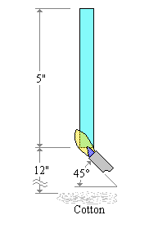

*Figure 2: diagram of UL 94 vertical flame test (blue bar is material being tested) [3]*

*Table 2: Rating criteria for UL94 vertical flame test [3]*

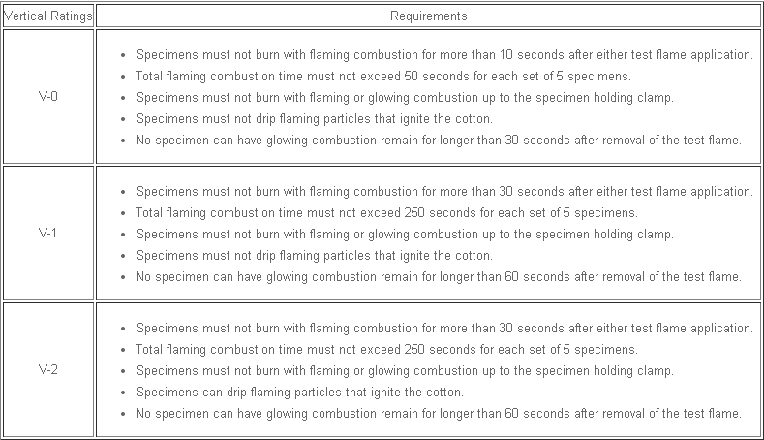

20% GFP falls under V-1 category for the vertical flame test. This means that the material will not drip flaming particles that ignite the cotton underneath it. The material will also not produce a large flame when in the presence of a flame. These properties make 20% GFP ideal because in the event of an accident, the expensive and delicate electrical components will not be damaged, making repairs much cheaper in the long run. However, there are two issues that make GFP unsuitable for the outer panels of the enclosed bike: GFP starts clear but will yellow over time with exposure to elements and GFP cannot be made easily in large intricate designs for outer panels. For these reasons a different material with similar properties will be used for the outer body panels.

* 1. Outer Panels

For the outer panels, Glass-Fiber Reinforced Polyester will be used. For the remainder of the report Glass-Fiber Reinforced Polyester will be referred to as FRP. Although FRP does not have the resistive properties of GFP, it is still quite durable and lightweight and can be made in large irregular shaped panels [4]. These panels will be able to provide added protection to the cyclist while remaining light enough for the cyclist to power the bike on his/her own. FRP can also be manufactured in virtually any colour or finish to provide a more attractive “sporty” appearance [4], and unlike GFP it won’t yellow over time. Another feature of FRP is that it is scratch and graffiti resistant, which will stop any spray paint from bonding to the surface of the panels and reduce the risk or repair costs due to vandalism. FRP is also a relatively inexpensive material. (*****

Space reserved for price per m2 of FRP compared to total surface area of bike (douglas) , Research still in progress

***********)